Provided by [B_Officialname]

Contents
Introduction 3
Return to Work Timeline 4
Office Closure 4
Phase One 4
Phase Two 4
Phase Three 5
Considerations 5
Workplace Protocols to Follow When Returning to Work 6
Employee Screening, Exposure and Confirmed Illness Protocol 6
Employee Screening Protocols 6
COVID-19 Exposure and Confirmed Illness Protocol 6
Reporting Transparency Protocol 7
Social Distancing Protocol 7
Employee Health and Safety Protocols 8
General Employee Health and Hygiene 8
Employee Mental Health Considerations 9
Cleaning and Disinfecting Protocol 9
Office Procedures 9
Conclusion 10

This sample plan is intended for informational purposes only and does not include state or local guidance related to COVID-19. In addition, it should not be used as legal or medical advice. Please consult a legal or medical professional for further advice. © 2020 Zywave, Inc. All rights reserved.

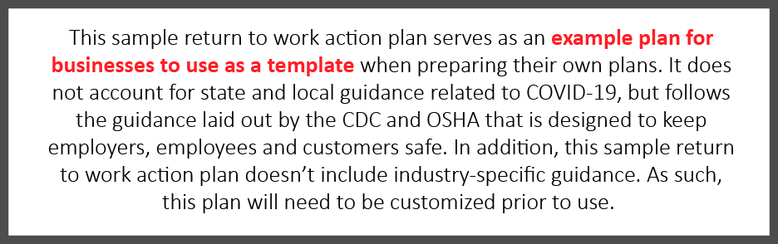

Introduction
At [C_Officialname], it is our priority to keep our employees and their families healthy, especially in the midst of the COVID-19 pandemic. As such, we will abide by governmental guidelines when possible as we strive to balance public health concerns with the needs of our business. This return to work action plan details how we plan to reopen our business and still keep all of our employees safe to every extent possible. This plan, which pulls from Centers for Disease Control and Prevention (CDC) and Occupational Safety and Health Administration (OSHA) guidance, highlights the responsibilities of managers and employees, and outlines the steps [C_Officialname] is taking to address COVID-19.
While we will implement various protocols to ensure your safety, it’s up to you and your co-workers to execute on these protocols daily. By releasing this return to work action plan, [C_Officialname] hopes to clearly communicate our plans moving forward, highlight workplace protocols in place to protect your safety and establish a level of comfort for all of our employees as we ask you to return to the office.
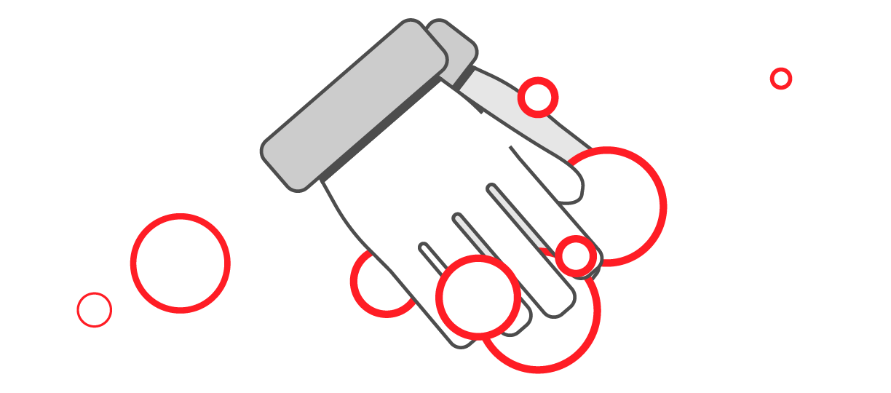
We understand that every employee’s situation is different and encourage those with specific risks or concerns to reach out to their manager or HR to discuss alternate arrangements, should they be necessary.

Return to Work Timeline
Due to the evolving nature of the COVID-19 pandemic, creating an exact timeline for resuming “normal” operations is not feasible. [C_Officialname] will continue to monitor applicable state and local guidance and determine next steps for reopening the office.
At this time, we’ve created a tentative phased approach for asking our employees to return to work. To remain consistent with federal guidance, our phased approach to reopening our office mirrors the guidelines included in the White House’s Opening Up America Again Guidelines.

Office Closure
This is the current stage we are in, as state and local guidance prohibits gatherings of 10 or more people. At this time, our office will remain closed to employees, vendors and visitors. Employees who are able to work remotely are asked to continue doing so until further notice.

Phase One
Under Phase One, the office may reopen. We will evaluate whether it is possible to open our office and permit a maximum of 10 essential employees to return to work. Social distancing protocols will be put in place and should be followed. However, any other employees who are able to do so should continue to remain home and work remotely. Under Phase One guidance from the government, nonessential travel should be avoided. Business-related travel will not resume under Phase One.

Phase Two
Under Phase Two, the office may reopen to more employees. Government guidance states that in Phase Two, gatherings of up to 50 people are permitted. As such, we will review our situation, consider opening our office and permit a maximum of 50 employees to return to the office. [C_Officialname] will observe governmental guidelines related to occupancy and capacity given our office’s square footage. Similar to Phase One, employees who are able to work from home should continue to do so. Access to the office will be granted for job roles that are critical to business operations or for employees who are not able to work remotely.
Should we reopen our office in this limited capacity, social distancing protocols will be put in place and workplace modifications may be made to ensure social distancing can be maintained throughout the workday. The following protocols will be put in place to ensure our headcount in the office does not exceed 50 employees and to promote social distancing efforts:
- Staggered and monitored schedules—[C_Officialname] will implement a tracking system for employees to request and record their attendance in the office. Additionally, rotating schedules will be used until all restrictions are lifted to minimize employee contact.
- Workstation modifications—[C_Officialname] will modify the office layout to create at least 6 feet of distance between employee workstations, and face-to-face desk layouts will be changed.
- Prohibition of in-person meetings—Until all social distancing requirements are lifted, [C_Officialname] bans in-person meetings. Instead, employees should conduct virtual meetings. Employees who are in the office should avoid gathering in groups.
In addition to the protocols mentioned above, [C_Officialname] may implement additional guidance during Phase Two that is designed to promote workplace safety.
Finally, although governmental guidance dictates that nonessential travel may resume under Phase Two, business-related travel will remain banned. A travel approval workflow will be implemented once the majority of states have entered Phase Two of the federal government’s plan. Any employee who travels should follow self-isolation guidelines and not return to work during the isolation to ensure the safety of their peers.

Phase Three
Under Phase Three, the office may reopen to all employees. We will consider reopening the office and implement various protocols to ensure the health and safety of our employees. At this phase, we may also consider resuming business-related travel.

Considerations
It’s important to note that these phases are tentative and are subject to change based on state and local guidance, and the pandemic itself. Should an employee test positive for COVID-19 after the office reopens, our plan may change in an effort to protect our employees. In addition, if cases of COVID-19 spike again in our state or in our local area, we will consider whether to remain open or close.
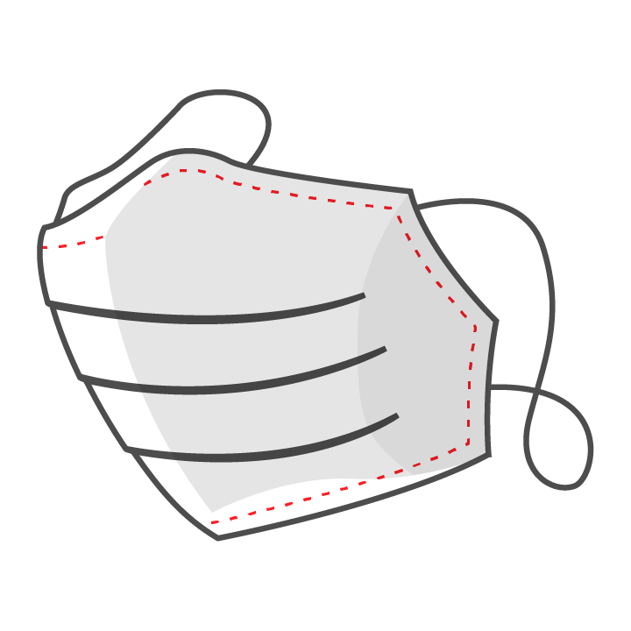
We recognize that each individual will need to make a personal decision as to when he or she is comfortable returning to the office based on individual circumstances. Please reach out to your supervisor, manager or HR to discuss your personal situation.

Workplace Protocols to Follow When Returning to Work
[C_Officialname] has implemented various workplace protocols designed to preserve the health and safety of our employees as they return to work. This section further explains these protocols. For additional information, please reach out to your manager or supervisor.

Employee Screening, Exposure and Confirmed Illness Protocols
Keeping employees safe is our priority. To accomplish this task, we have created various procedures for screening employees who return to work, dealing with exposure to COVID-19, responding to a confirmed case of COVID-19 and reporting transparency.

Employee Screening Protocols
The Equal Employment Opportunity Commission permits employers to measure employees’ body temperatures before allowing them to enter the worksite. Any employee screening will be implemented on a nondiscriminatory basis, and all information gleaned should be treated as confidential medical information—specifically, the identity of workers exhibiting a fever or other COVID-19 symptoms should only be shared with members of company management with a true need to know.
[C_Officialname] employees may be asked to confirm the status of their health as part of working in the office. The company reserves the right to implement a screening protocol for symptoms, such as temperature checks or signed certifications, at any point. Results will be tracked separately from any personnel records and will be kept confidential. This protocol will commonly be implemented upon initial opening of the office and as a response to a confirmed diagnosis. Employees unwilling to complete a screening will be required to work remotely.

COVID-19 Exposure and Confirmed Illness Protocol
Employees who test positive for COVID-19 or believe they have been infected will be instructed to follow the advice of a qualified medical professional and self-quarantine. When self-quarantining, employees should:
- Stay away from other people in their home as much as possible, staying in a separate room and using a separate bathroom if available.
- Not allow visitors.
- Wear a face mask if they have to be around people.
- Avoid sharing household items, including drinking cups, eating utensils, towels and bedding.
- Clean high-touch surfaces daily.
- Continue monitoring their symptoms, calling their health care provider if their condition worsens.
Notably, employees who are symptomatic or who have tested positive should not return to work until the conditions outlined in the table on the next page are met:

Return to Work Considerations
Employee was symptomatic but was not tested for COVID-19. | Employee was tested for COVID-19.
The employee may return to work if:  - They have not had a fever for at least 72 hours and have not used fever-reducing medication during that time.  - Coughs and other symptoms have improved.  - Seven days have passed since they first experienced symptoms. | The employee may return to work if:  - They no longer have a fever.  - Coughs and other symptoms have improved.  - They have received two negative COVID-19 tests in a row.

When an employee tests positive for COVID-19, deep-cleaning procedures will be triggered. Furthermore, employees who have been in close contact with an individual who has tested positive for COVID-19 will be instructed to self-quarantine.

Reporting Transparency Protocol
Any [C_Officialname] employee who experiences COVID-19 symptoms or has tested positive for COVID-19 must notify HR as soon as practicable. The employee will be asked to assist with contact tracing. This information will be tracked separately from personnel records, and names will not be released. Depending on the circumstances, [C_Officialname] will notify impacted employees if there is a confirmed case of COVID-19 in the workplace. [C_Officialname] may elect to close the office for a period up to 72 hours following a confirmed case to allow for natural deactivation of the virus.

Social Distancing Protocol
Employees should follow social distancing best practices while at [C_Officialname]’s facilities, including but not limited to workstations, cafeterias, common areas and office spaces. Specifically, employees are asked to:
- Stay 6 feet away from others when working or on breaks. Where a minimum distance cannot be maintained, engineering or administrative controls will be in place.
- Avoid job tasks that require face-to-face work with others when possible.
- Avoid contact with others whenever possible (e.g., handshakes).
- Avoid touching surfaces that may have been touched by others when possible.
- Distance themselves from anyone who appears to be sick.
- Avoid gathering when entering and exiting the facility. Employees should also only enter and exit designated areas.
- Follow any posted signage regarding COVID-19 social distancing practices.
- Disinfect their workspace often.
- Avoid touching their face.
- Avoid nonessential gatherings.
- Stagger lunches to limit the number of individuals in the break room or cafeteria.
- Avoid using common areas.
[C_Officialname] may extend our social distancing guidelines after the office reopens. Please monitor your email and adhere to any additional guidance as it is provided.

Employee Health and Safety Protocols
The success of our return to work action plan relies on how well our employees follow social distancing and health and safety protocols. As such, the following protocols have been implemented to ensure your health and safety. Please bring any concerns regarding the following protocols to a manager or supervisor immediately.

General Employee Health and Hygiene
Practicing good hygiene is essential to prevent the spread of COVID-19. Do your part by practicing good hygiene at work and at home:
- Regularly wash your hands for at least 20 seconds throughout the day with warm water and soap, specifically before eating.
- Cover coughs and sneezes.
- Avoid touching your eyes, nose and mouth.
To help employees remain healthy, [C_Officialname] has hand sanitizer and disinfecting wipes available throughout the office. We have limited amounts of these supplies and will continue to restock as we are able. It is suggested that employees wash their hands more frequently than normal. Additionally, building management has instructed the office cleaning crew to disinfect key areas such as faucets and door handles on a daily basis.
In addition, employees are strongly encouraged to wear face coverings when in public and when physical distancing of 6 feet or more cannot be guaranteed. Employees will provide their own face coverings in accordance with CDC guidelines. It is recommended that employees wear face coverings when entering and exiting the building and when using common areas such as bathrooms, kitchens and the lobby. [C_Officialname] will maintain a small inventory of disposable masks and gloves as a backup to employee-provided PPE. Inventory quantities will be regularly tracked and documented but cannot be guaranteed.
Finally, employees who are feeling sick are asked to stay home from the office. Employees who have symptoms of acute respiratory illness, should immediately seek medical attention and follow the guidance of a health care provider. Employees with symptoms are required to work remotely or take PTO. Employees who have been diagnosed with or are aware they’ve been directly exposed to COVID-19 should notify HR.

Employee Mental Health Considerations
[C_Officialname] understands that the COVID-19 pandemic has increased stress levels of employees across the country. We want to prioritize our employees’ mental health during these uncertain times. As such, we have made every effort to ensure that the workplace is safe for employees to return to work and are ready to discuss personal situations. Managers and supervisors are aware of mental health considerations during this transition. Employees with concerns regarding their mental health should request additional resources from their manager or supervisor.

Cleaning and Disinfecting Protocol
Employees should do their part to help keep the office as clean as possible by cleaning and disinfecting their workstations and surfaces they commonly use. Employees should also avoid using others’ workstations, tools and equipment. Additionally, whenever an employee uses a common piece of equipment (e.g., printer or fax machine), it should be wiped down prior to and following use. Proper cleaning and disinfecting supplies will be provided by [C_Officialname]. Employees should wash their hands with warm water and soap for at least 20 seconds after cleaning or sanitizing a surface.
[C_Officialname] has requested that building management facilitates cleaning of common areas and other frequently touched surfaces throughout the day. The frequency of this cleaning may change depending on the situation.

Office Procedures
In addition to the guidance outlined above, [C_Officialname] has implemented the following workplace procedures to be followed until social distancing guidelines are lifted:
- Deliveries—[C_Officialname] will set up contactless drop zones for all deliveries, including mail and packages. An assigned contact or contacts will process mail and packages at least three times per week, utilizing gloves. Employees ordering food delivery service will need to instruct drivers to utilize drop off zones for contactless delivery.
- Visitors—Until further notice, all nonessential visitors are prohibited and any interviews should be conducted virtually. For business-critical visits (e.g., material deliveries), [C_Officialname] will take steps to safeguard employees and visitors by:
  - Requiring visitors to go directly to their assigned work area without unnecessarily interacting with employees.
  - Requiring visitors to practice social distancing and good hygiene while on-site.
- Vending and catering services—To ensure the health of employees, [C_Officialname] will observe governmental guidelines and restrictions related to self-serve vending stations. In the absence of vending, employees will be responsible for bringing their own food and beverage, preferably in a temperature-controlled bag. It is recommended that all dishware be taken home nightly for cleaning in a dishwasher. The company will avoid catering events that allow for cross-contamination.
[C_Officialname] may add to this list of workplace procedures as employees return to work. Employees should monitor workplace communications to ensure they’re up to date on all health and safety communications.

Conclusion
[C_Officialname] looks forward to the future of our employees returning to work. The COVID-19 pandemic has created uncertain times and resulted in unprecedented workplace changes. As communicated throughout this return to work action plan, we are prioritizing the health of our employees every step of the way as we consider reopening our business’s doors.
We will execute on our plan cautiously, following applicable state and local guidance as much as possible. We also understand that each employee’s needs and situations will be different as our doors begin to reopen. Employees should discuss any concerns they have about returning to work as it relates to their personal health or situation with their manager or supervisor.
Finally, we ask that employees are patient and understanding of the fact that the COVID-19 pandemic may require our return to work plans to change. Employees will be given as much notice as possible in the event of an unforeseen setback or office closure.
Employees should direct questions regarding the content of this action plan to their supervisor. Furthermore, while the strategies highlighted in this document can protect workers from COVID-19, it’s important to follow CDC guidance at all times. For more information, click here.

